CO2 ASSESMENT 1
1.University Student Management systems:
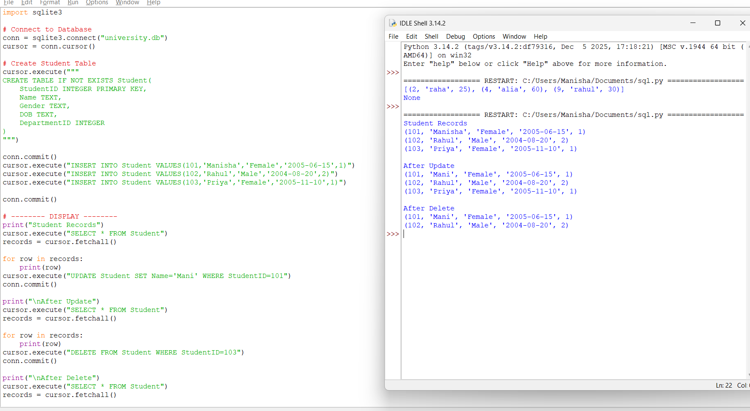
2.Hospital Patient Record Management Systems
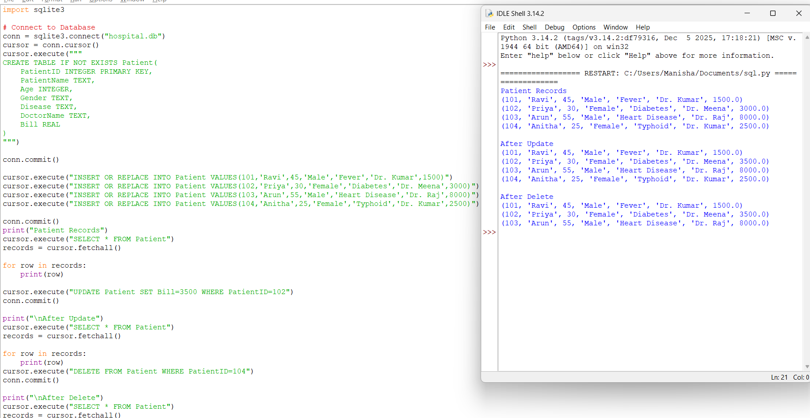

3.E-commerce Online Shopping Platform
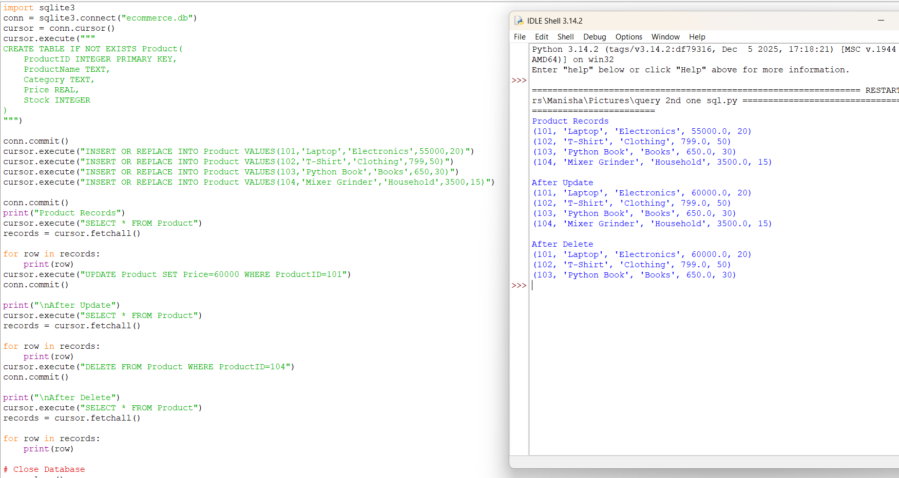
Scenario 4: Library Management System
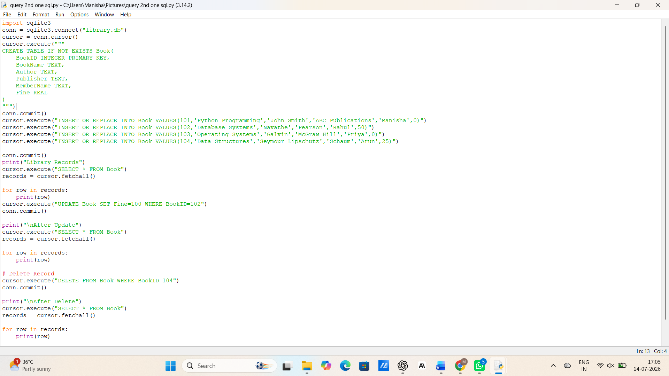

OUTPUT
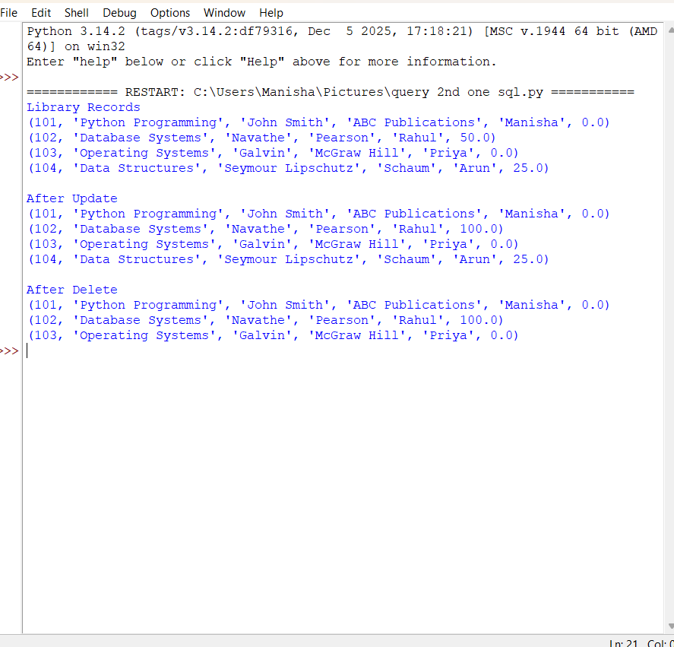
Scenario 5: Hotel Reservation and Booking System
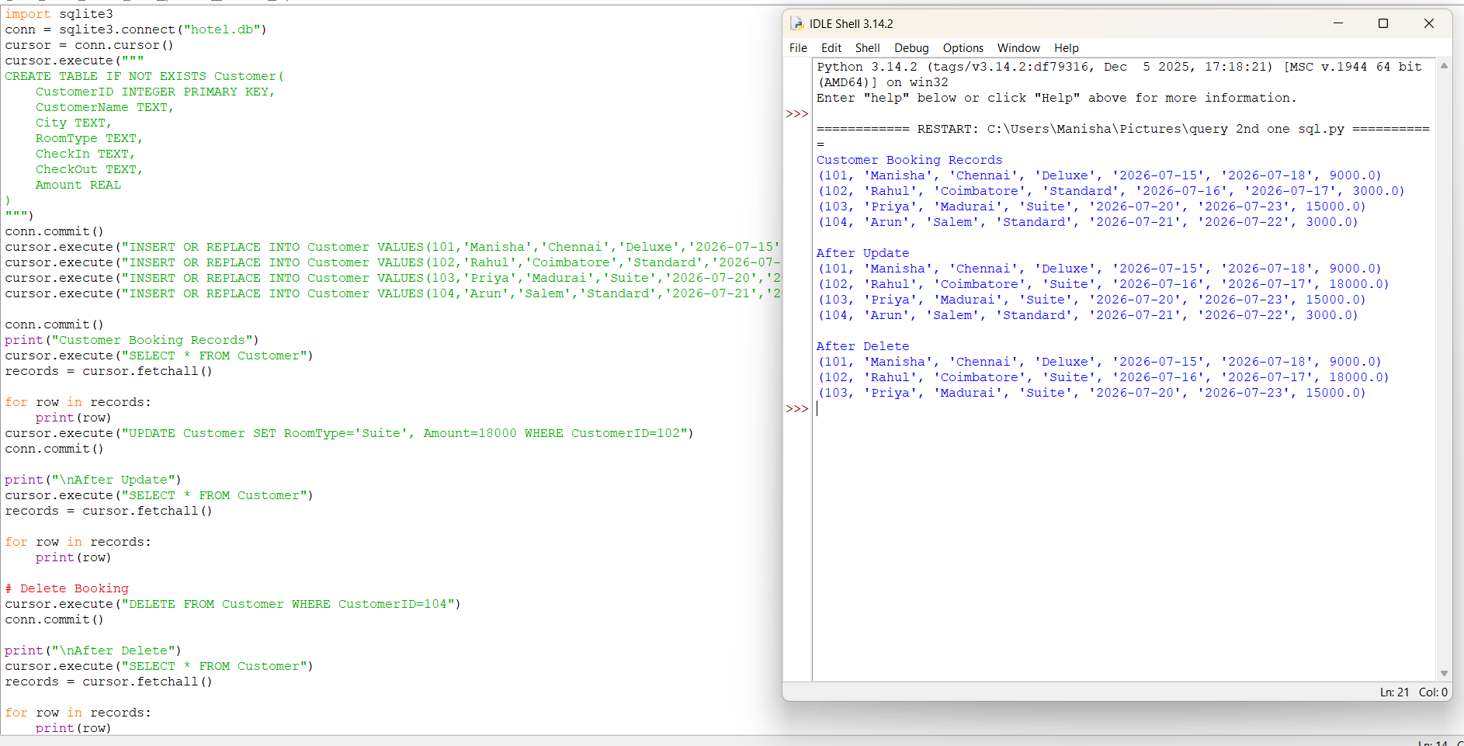

Scenario 6: Banking and Customer Account Management System
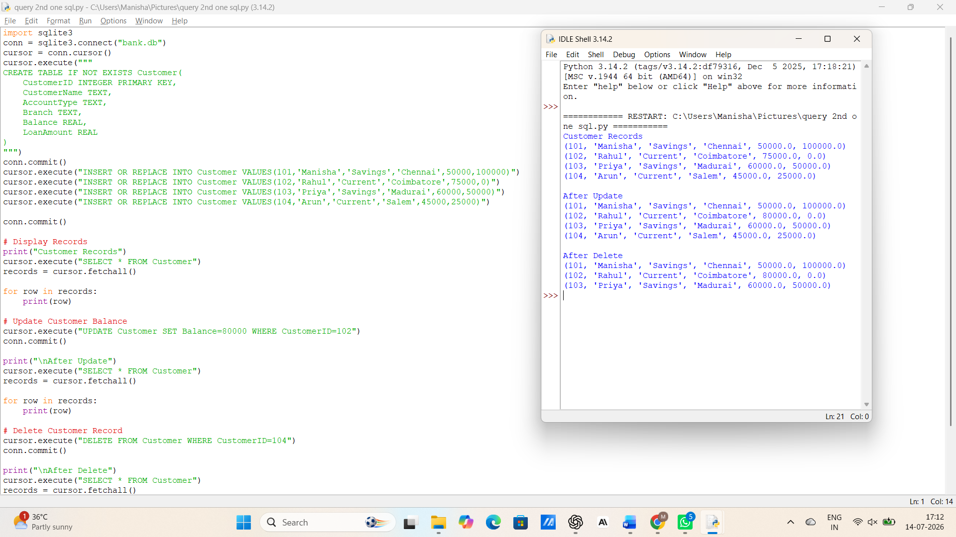
Scenario 7: Food Delivery Application
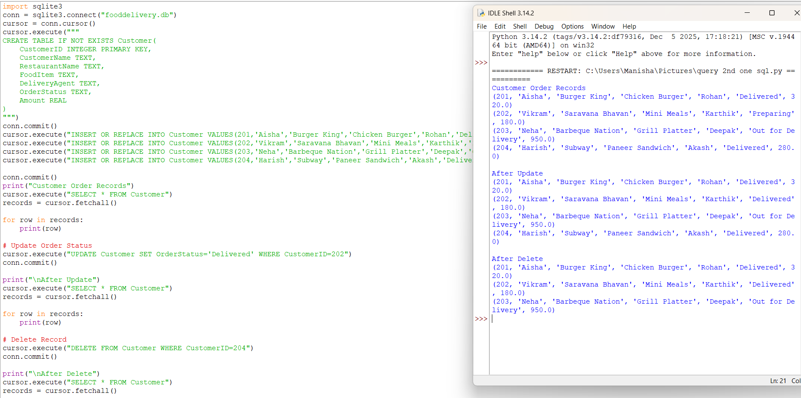
Scenario 8: Employee Payroll Management System
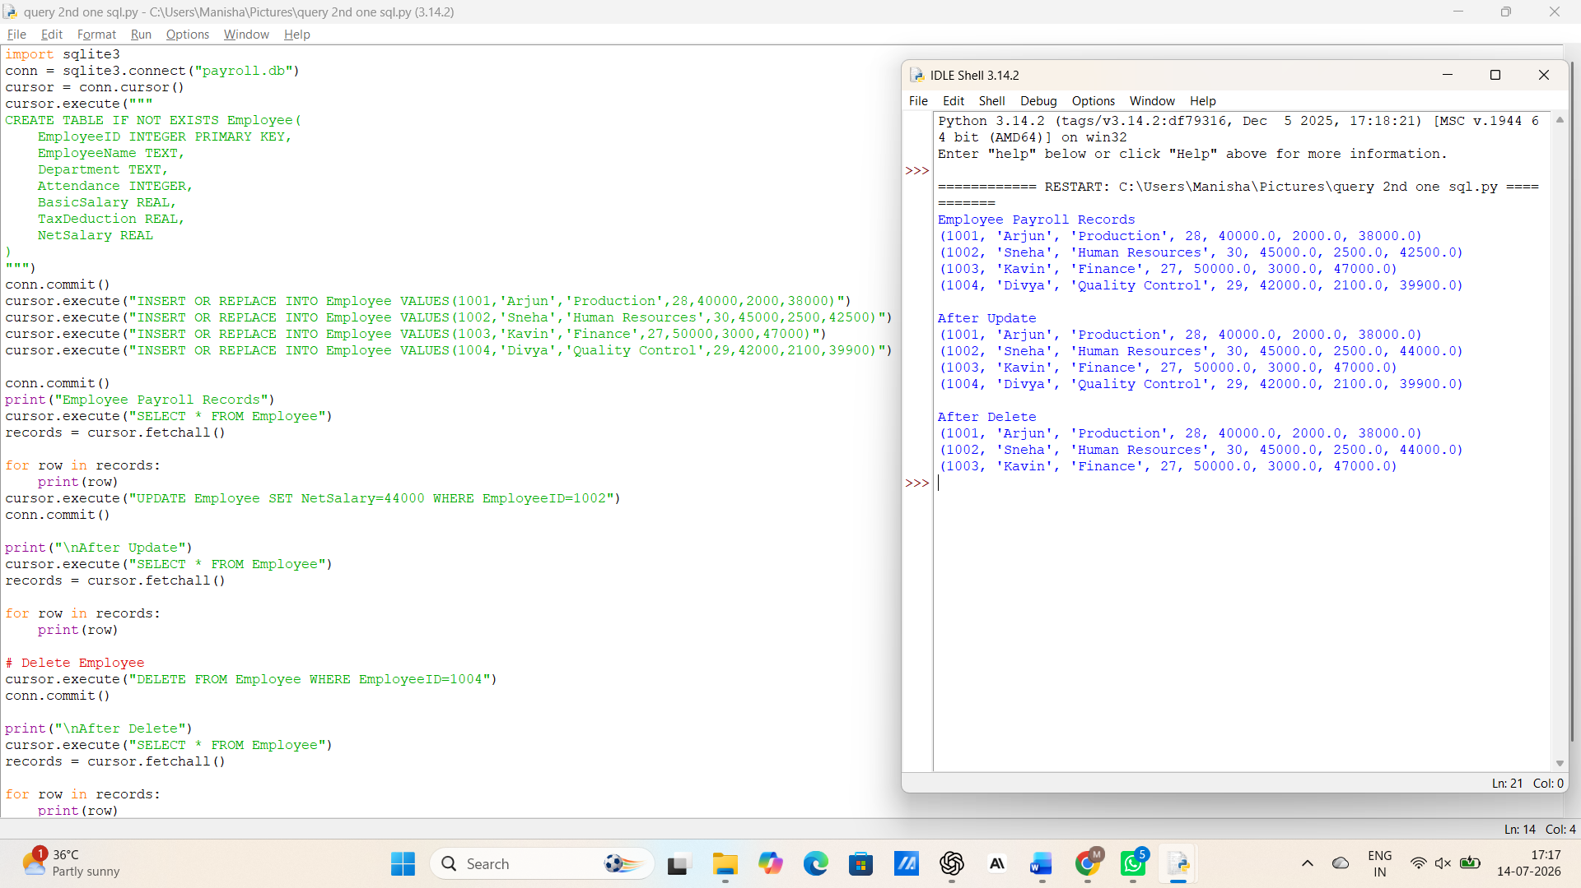
Scenario 9: Online Learning Management System
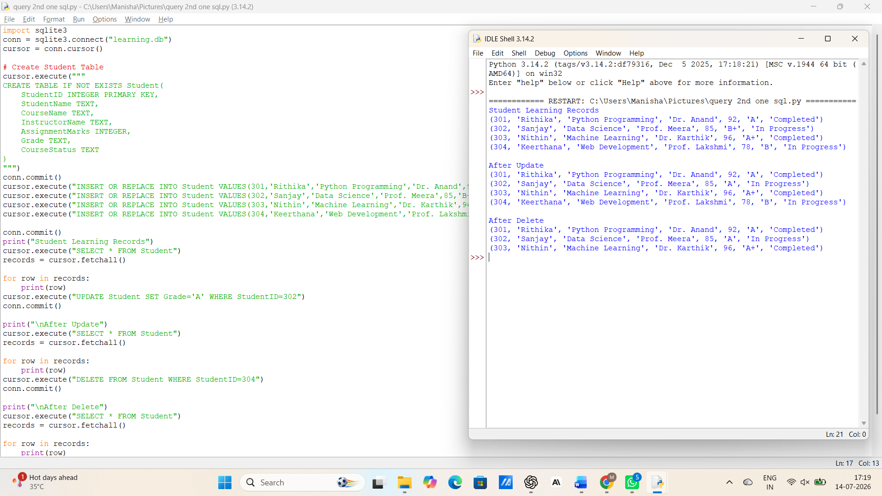

Scenario 10: Smart Transportation and Ticket Booking System
